

ADPQ Knowledge Base User Manual



3/16/2018

Table of Contents

1. Introduction 1

1.1 Logging into the Application 1

2. Content Management 1

2.1 Adding New Articles 2

2.2 Viewing Articles 3

2.3 Searching Articles 4

2.4 Editing Articles 4

2.5 Deleting Articles 5

2.6 Approving Articles 5

2.7 Archiving Articles 6

3. Users Management 6

3.1 Editing Users 6

3.2 Deleting Users 6

3.3 Dashboard 7

1. Introduction

Knowledge Management Tool is a comprehensive collaborative tool that helps to seamlessly share knowledge across cross-functional teams and organizations. Using this tool, employees can share, contribute, organize, and discover information making collaboration easier and more effective. This tool supports responsive UI (Mobile and Tablet view).

* 1. Logging into the Application

General users and Managers can log into the application using valid credentials to display the landing/home page.

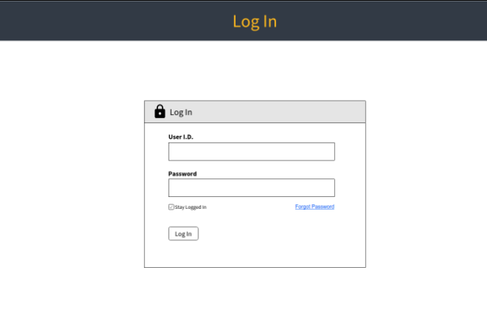

1. Content Management

The landing page displays a list of articles added to the knowledge base. Users/Managers can also see a search box that allows the user to search for a particular article. The left panel displays a navigational menu.

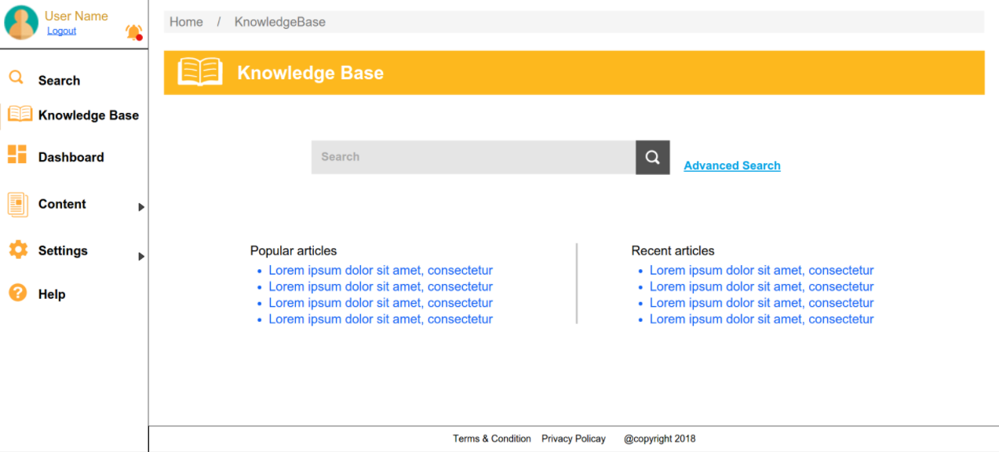

* 1. Adding New Articles

An article General Users or a Managers. Articles can be added to the knowledge base with the help of the **Articles** option available on the left menu panel.

To add a new article:

1. Select the **Articles** option from the left menu panel.
2. Click **Add Articles**.

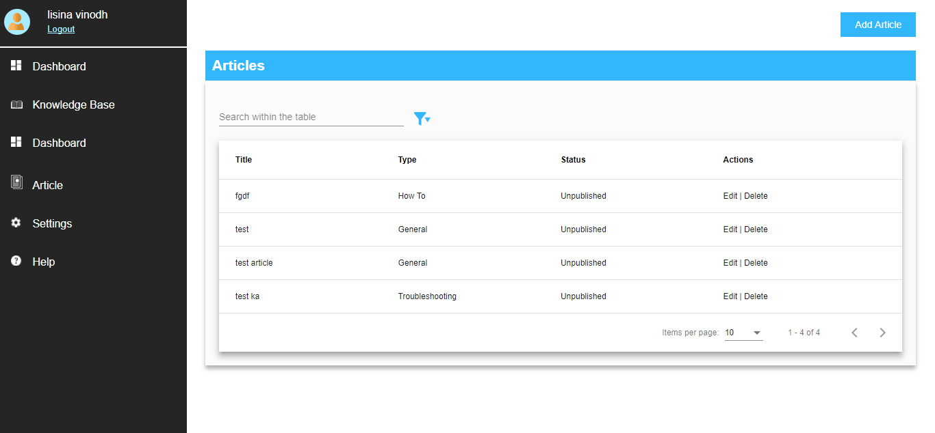

1. In the **Add Articles** page, enter the **Title**, **Description** and select the **Type.** There can be 5 different types of KAs. Files can be uploaded usingthe **Add File** button.

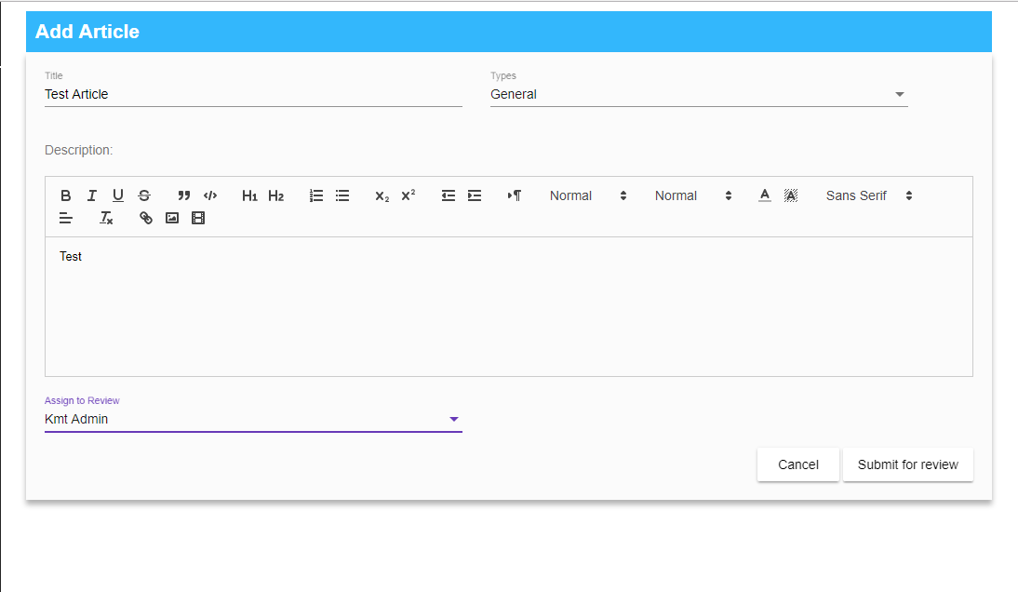

1. From the **Assign to Review** drop-down list, select a reviewer.
2. Click **Submit for Review**.
   1. Viewing Articles

General Users and Managers can view articles.

* Managers can view the articles they have added or the articles that have been sent to them for review or approval.
* General users can only view the articles they added with a published/unpublished status.

To view articles, select the **Articles** option from the left menu panel.

The **Articles** screen consists of four different columns that display the **Title, Type, Status** and **Actions.** A maximum of 50 records can be seen at a time on the page.

To open a specific Knowledge Article, click on any title.

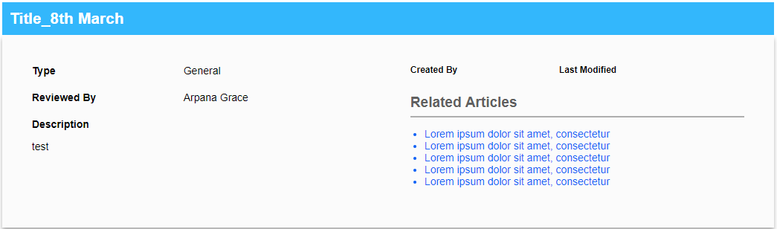

* 1. Searching Articles

A search can be done on the **Articles** page, using the **Title, Type or Status** columns. Advanced filtering can also be done using the **Status** and **Role** columns.

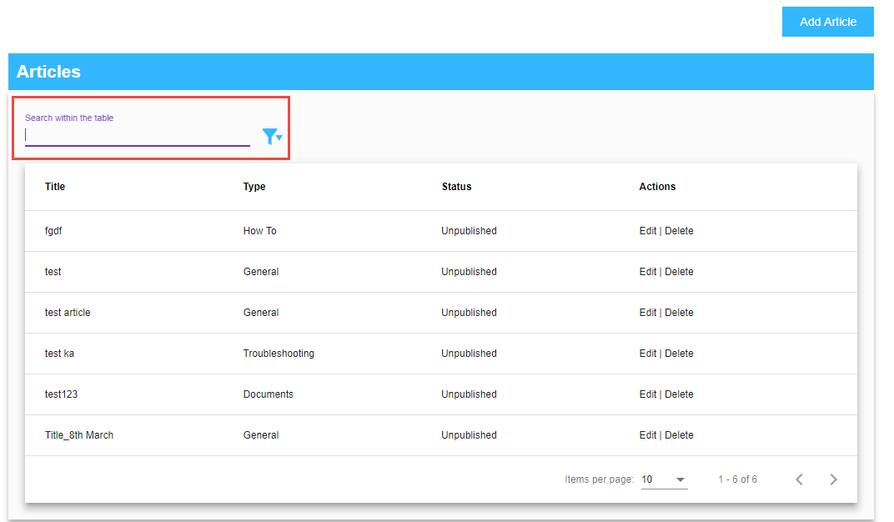

* 1. Editing Articles

Manager and General Users can only edit the articles they have added.

To edit an article:

1. Select the **Article** option from the left menu panel.
2. Click the **Edit** link against the article.

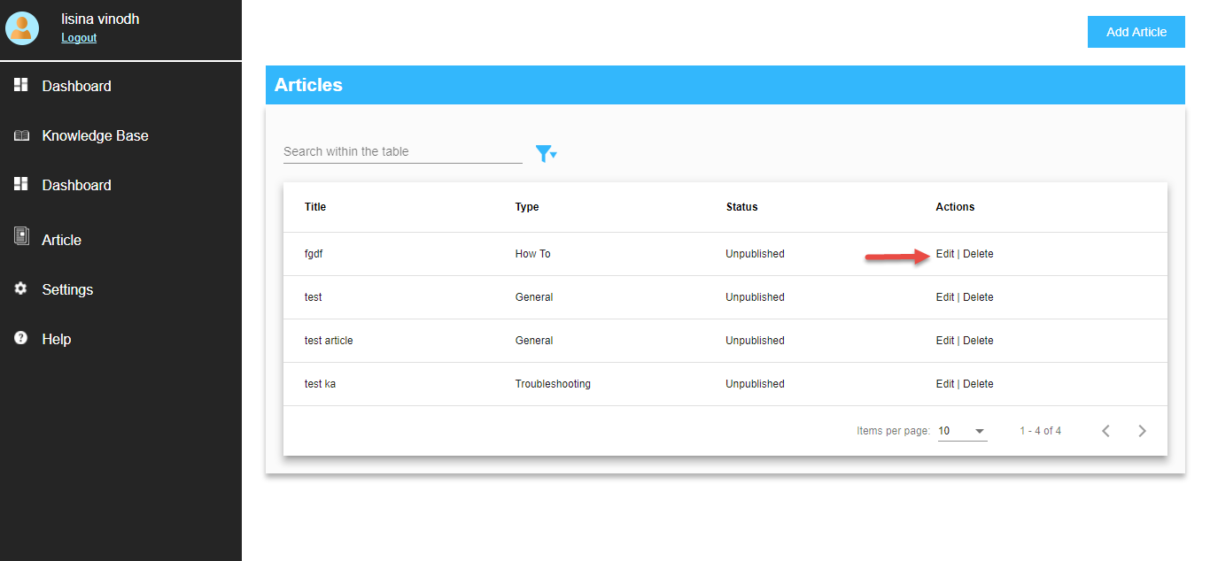

1. Once the appropriate changes have been made, select a reviewer from the **Assign to Review** drop-down list.
2. Click **Send for Review**.

You can view the **Last Modified** date and the name of the user who created the article.

NOTE: Published and unpublished articles can be edited.

* 1. Deleting Articles

Manager and General Users can only delete articles they have added.

* 1. Approving Articles

Articles can be approved either by Admin or Managers.

* Managers can approve only the articles assigned to them.
* General Users cannot approve articles.

When an article is sent for review, the assigned reviewer gets a notification to review the article. If the article is not reviewed within 5 days, a notification mail is sent on the 4th day to the creator of the article, requesting to change the reviewer.

To approve an article,

1. Select the **Article** option from the left menu panel
2. From the list of articles, click on the **Assigned to Me** link
3. Click Approve

Once approved, the article is published.

If the Admin/Manager clicks the **Review Comments** button, the comments can be entered in the text box and a reminder is sent to the user who created the article. The status of the article changes to unpublished.

* 1. Archiving Articles

Articles can be archived by Admins, Managers and General users. Deleted articles are moved to the archive folder and are not searchable.

* Admin can archive all articles.
* Managers and General Users can only archive the articles they have added.
* A General user can archive the articles added only by him.
  1. Dashboard

Managers and Users can view the Dashboard.

The Knowledge Base dashboard gives some overall information about the pending content approvals, along with the recently added and recently edited contents. Pending approvals can be approved or rejected from here.

